# Papers Please

The user plays an immigration officer for the state of Arstotzka who is responsible for the flow of people entering the state. The player makes their decisions based on the documents available to them; these include travel papers and the Government’s inspect, search and fingerprints databases. When the player first starts, they only need to check passports. However, as the game progresses the player gains access to more possessions (ID, work permits, jewelry etc.). Moral decisions and dilemmas are presented to the player as they must consider the needs of the vulnerable immigrants they encounter while fulfilling the duty they owe their country.

## Mechanics

Papers Please is played on one screen split into 3 sections. The top screen is unplayable and displays the queue of immigrants and the country's borders. The bottom left screen allows the player to interact with the traveler in front of the queue. Any communications are shown in bubble messages. The bottom right screen allows the player to view the documents (or possessions) in hand. This is also where the player, as the immigration officer, stamps approvals or rejections on the travelers'’ documents.

Figure 1 Basic POV showing the 3 sections of the screen

## Art and graphics

Papers Please feature pixel art and a limited palette of colors overall. This should be easier to draw and animate (hopefully). The game’s developer has some YouTube videos where they show the process of drawing their characters. See [Please: Drawing Faces](https://www.youtube.com/watch?v=tpro349xhXo).

## Twist

The user plays a university student in Bristol who is responsible for passing their degree. To pass each module, the player must face their lecturer in a battle. The battles become more challenging as the game progresses, and as the player gets closer to graduating their degree. Between the battles, the player must make difficult choices which include going out to the club or pulling an all-nighter for an assignment. These decisions affect the player’s health in the subsequent battle.

We adopt the graphics and mechanics of Papers Please, making use of the top unplayable section on the screen. The top screen can be where the player engages in the battles. The bottom left screen allows for interactions with fellow university students, TA’s and lecturers. These interactions are important for instructions and storytelling. The bottom right screen is where the player is allowed to make decisions that a typical university student makes daily. These include social and academic sacrifices. This aspect of the game is merely for filling the gaps between the levels and gauging attention. An interesting idea to implement is letting these decisions affect the abilities of the players at the next level. (This could be compared to situations in Papers Please e.g., bribery, which affect the storyline based on the player’s decision).

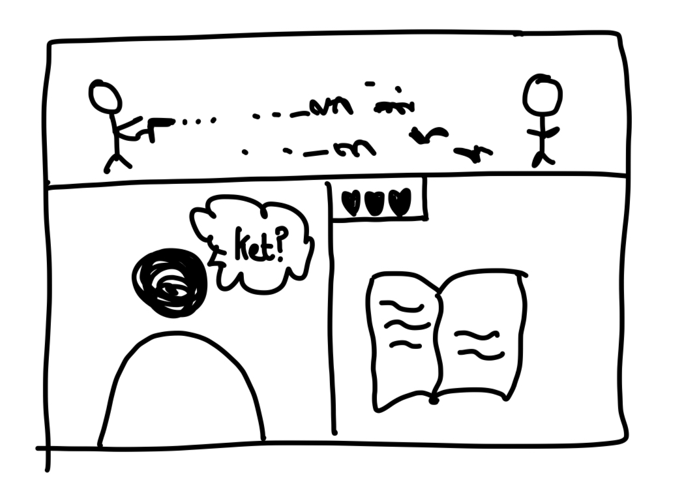

Figure 2 concept for screen view

## Levels

|  |  |  |
| --- | --- | --- |
| Name | Power | Attributes |
| Noel Cowbell | Throws verbal abuse at you | 1. Has an army of cow minions 2. Wears a cardigan |
| Johnny Meowskas | Programs robots to attack you |  |
| Jo Halibot | Charges at you to attack | 1. Wears a Hawaiian shirt 2. Tells you to use Linux |
| The U1 | You must catch the bus. Beware of the infamous Bristol delays. | 1. Drives away from you |

## Characters

* TA’s (they help with instructions, tips and hints)
* ALT girl/guy: Wolfe Kutt and Lana Deth
* Rugby lad/ hockey girl: Jack Letackle and Maverick Mulleston
* Nitty: Spud
* Neek
* Failing DJ: Sir Doesn't Mix-a-Lot
* Trust fund kid: Rufus Henry Cuthbert-Smythe

## Concept ideas

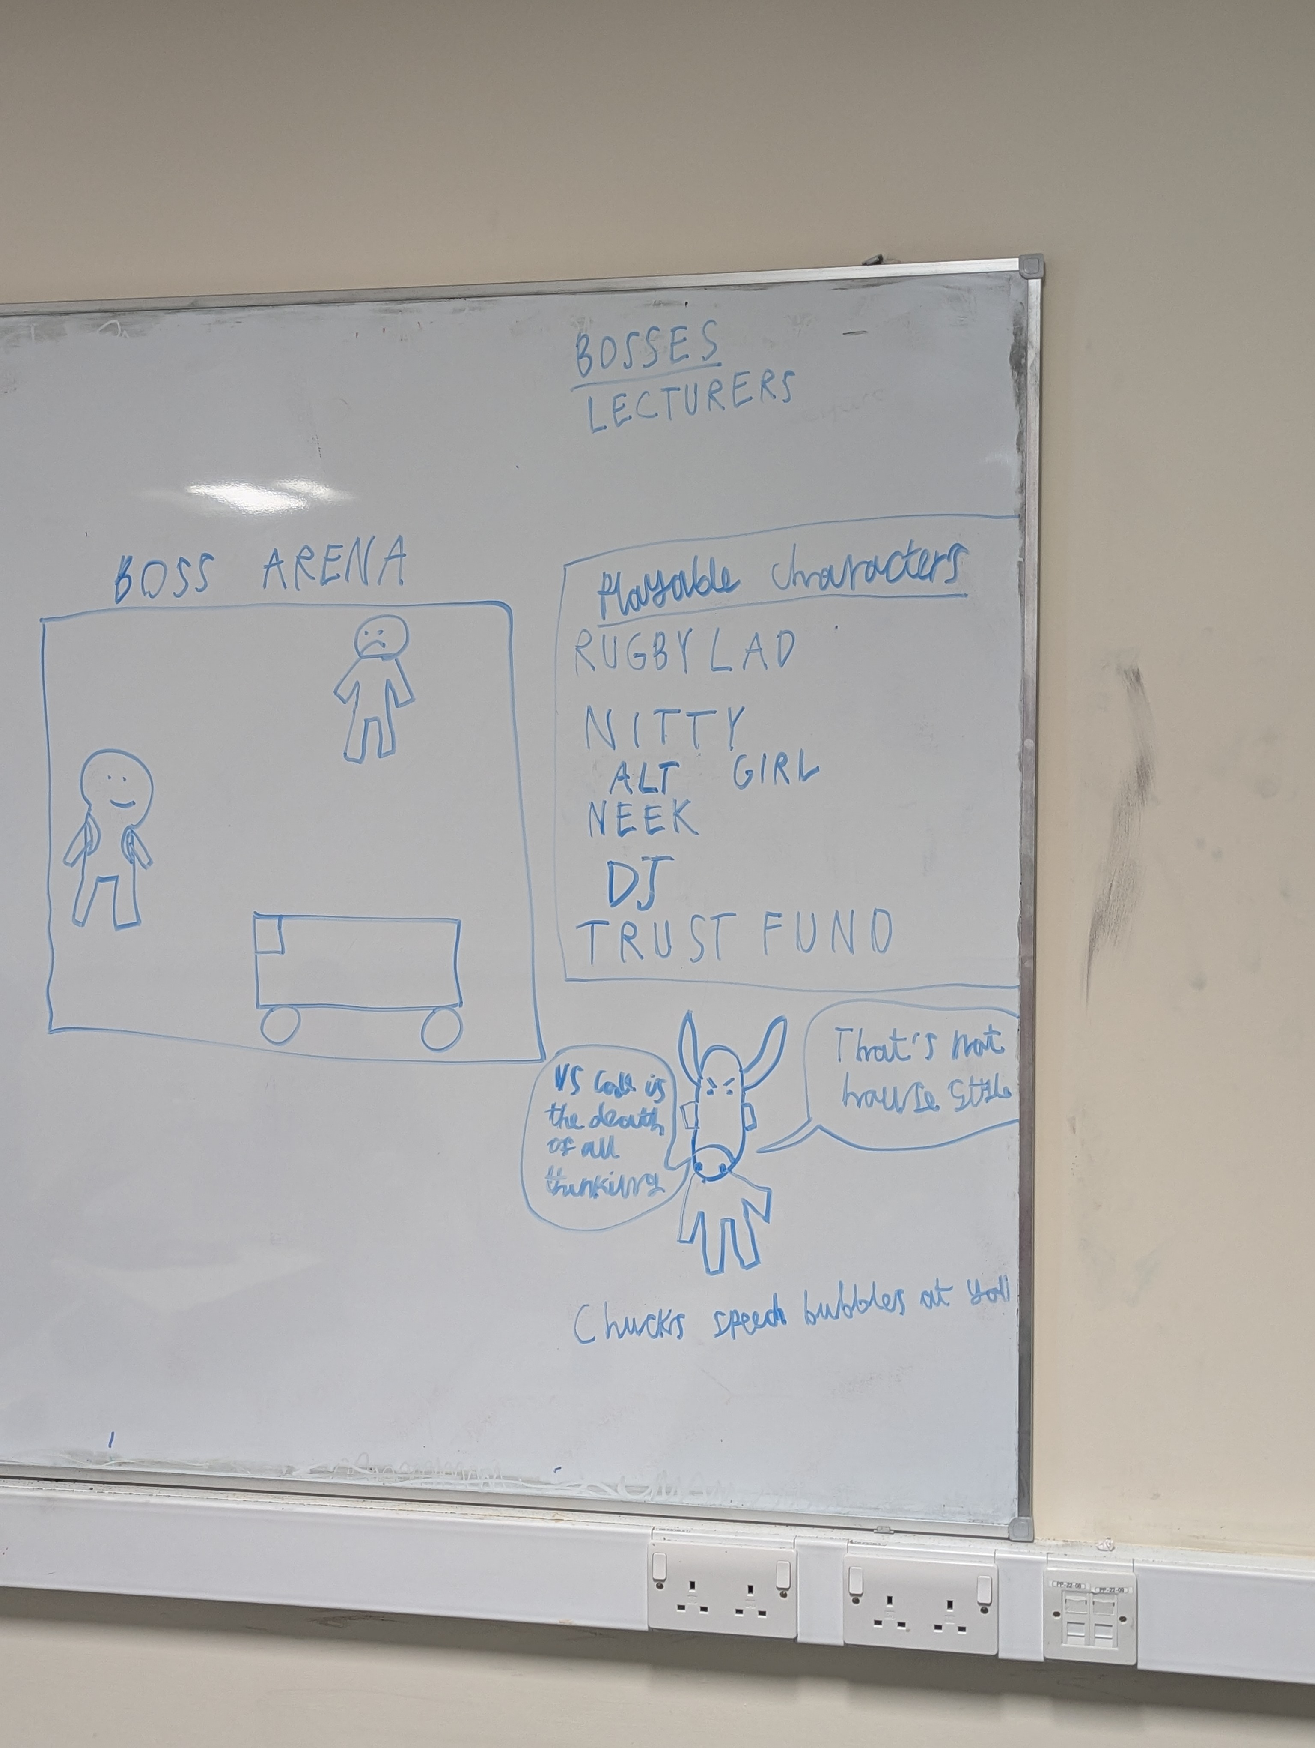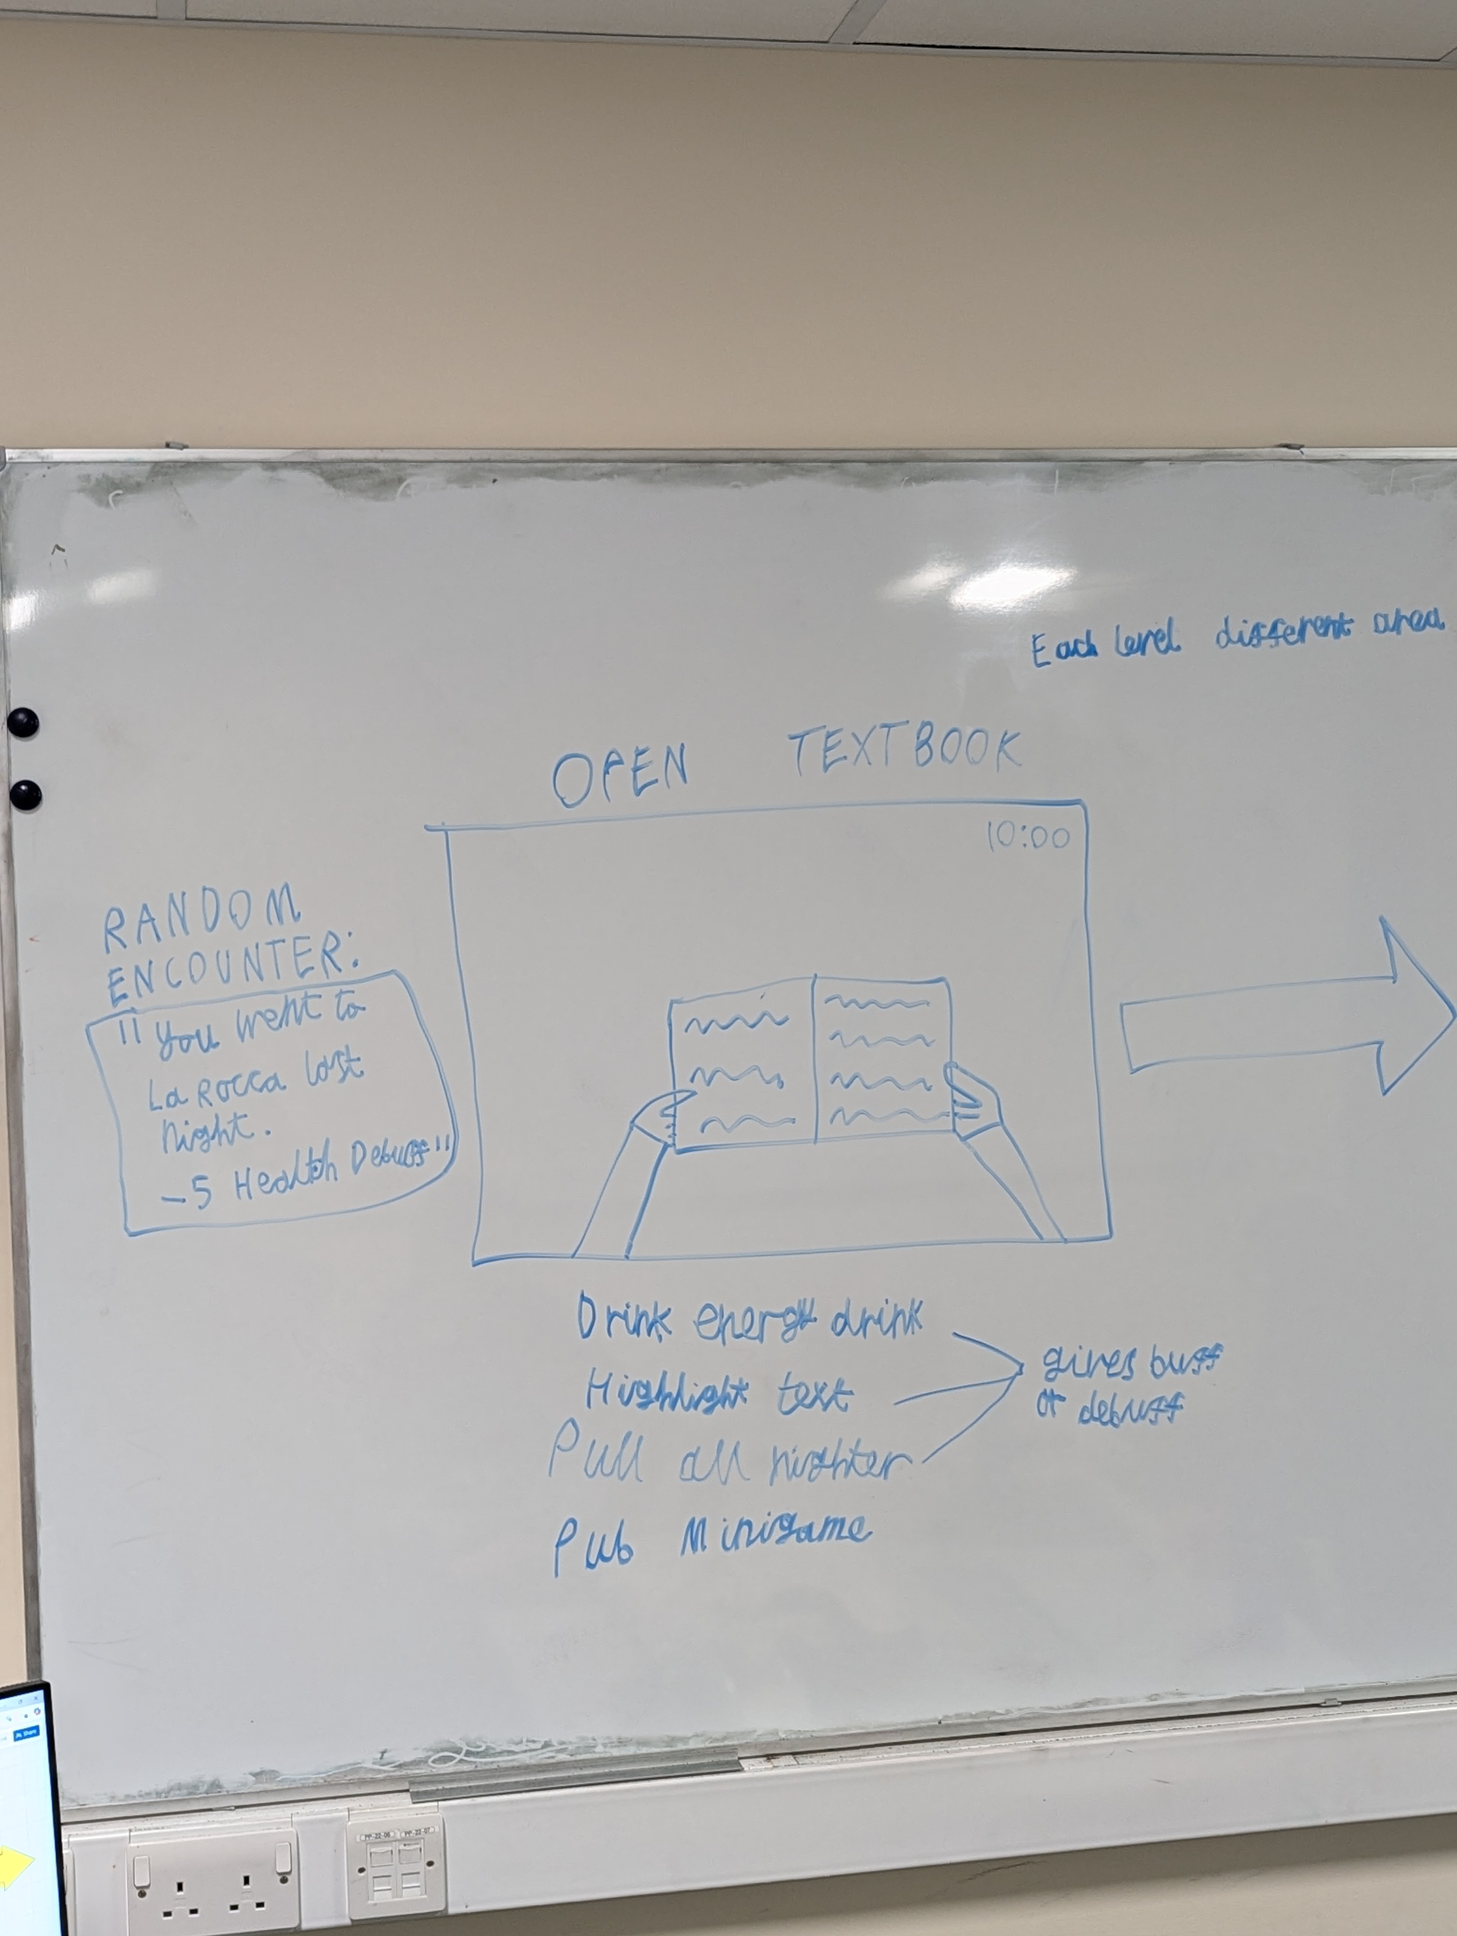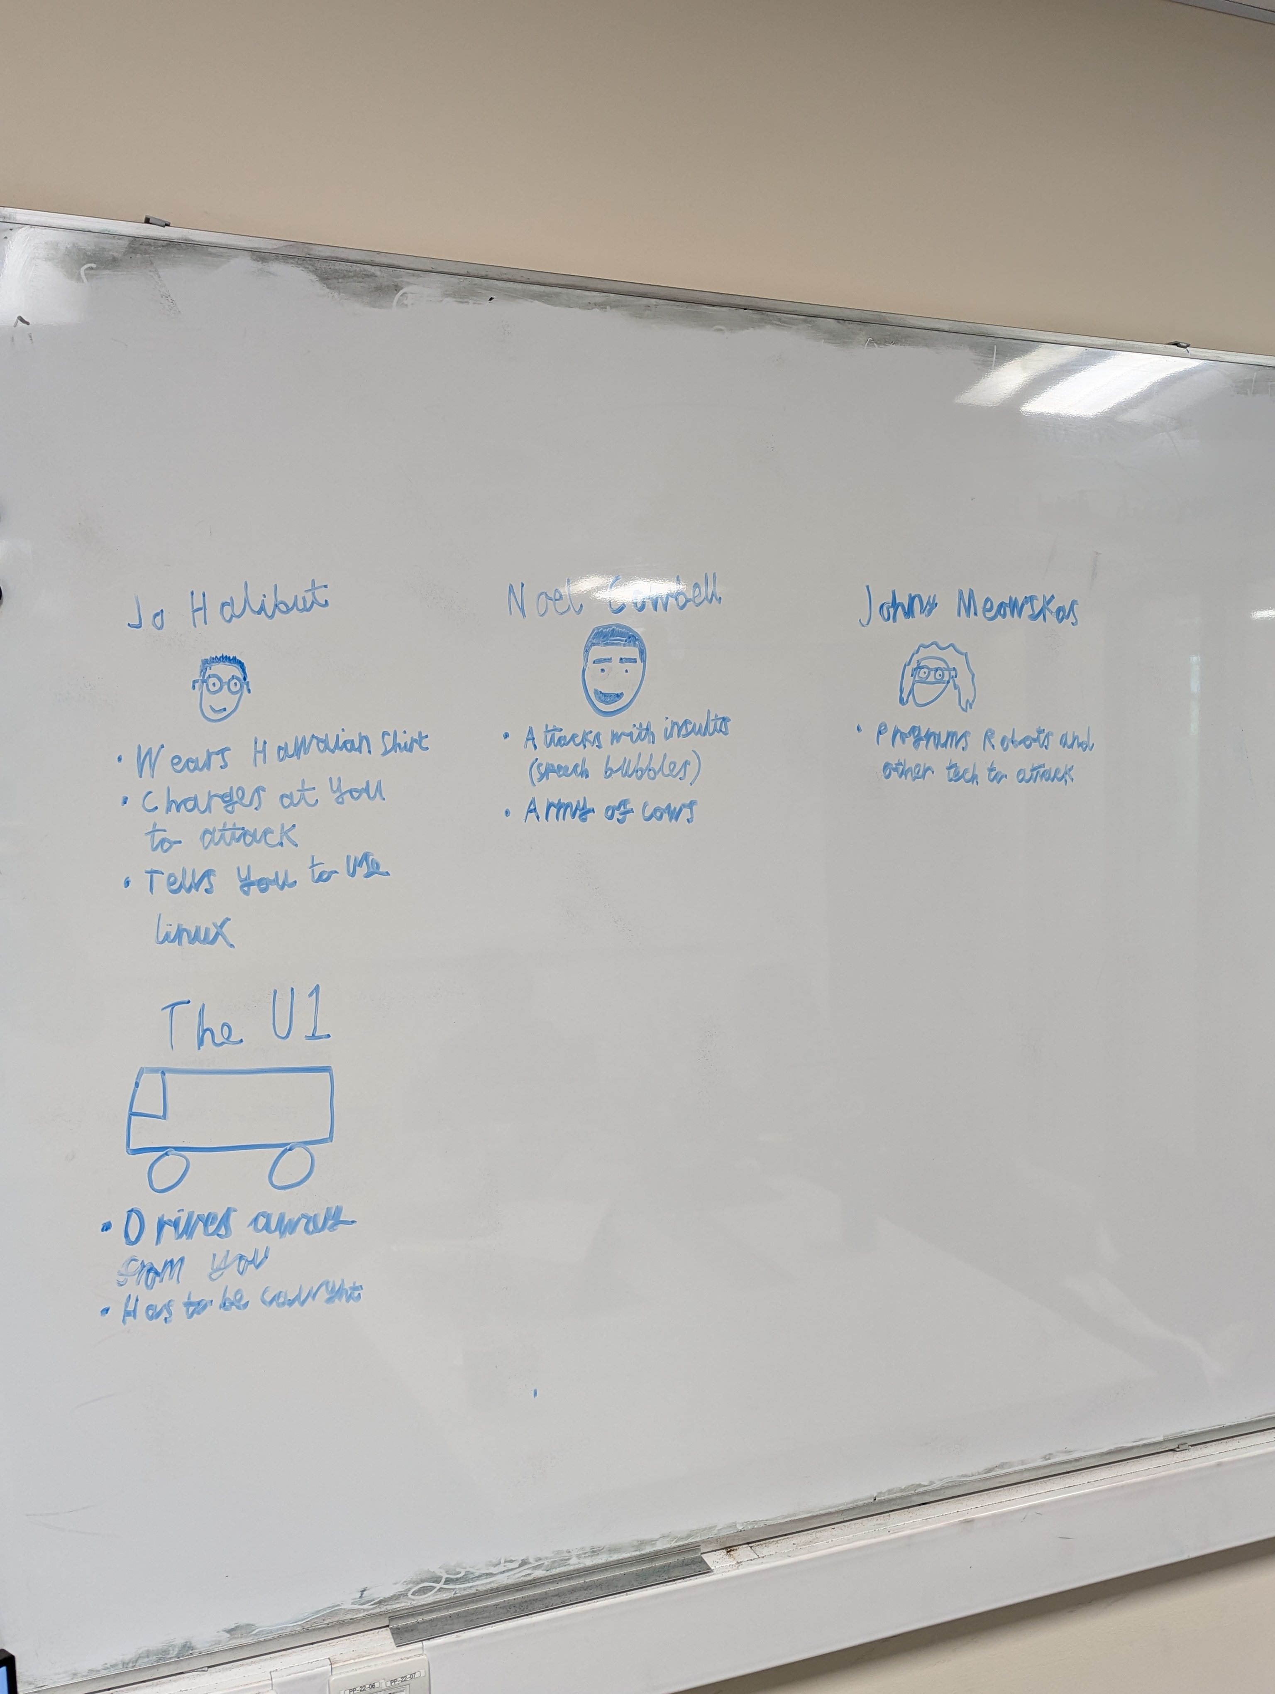

## Additional inspiration

* The Sims
* Bitlife